**Table of Contents**

1. Abstract
2. Introduction
3. Carbon Flux and Its Importance
4. Stokes Law and Predicting Sinking Speeds  
   A. Global Maps of Important Environmental Variables that are measured by satellite (T, S, μ)  
   B. Particle Size and Sinking Speed Estimates  
   C. Particle Size Distribution and Global Carbon Flux Estimates
5. Sediment Trap Data
6. Comparisons Between Data
7. Discussion
8. Citations

**Abstract**

The abstract will outline the essential topics of the thesis and condense it into a short and digestible package.

**Introduction**

The introduction will give background to the paper, reference relevant papers (Kostadinov et. al 2009, 2016, MIT Seawater Papers, Mouw Dataset), as well as stating the main points of the thesis: The mathematical concepts of Stokes Law (force balance between gravity and the friction of the fluid), satellite data and its resulting plots, comparisons sediment trap data. It will also outline the general structure for the paper.

**Carbon Flux and Its Importance**

Carbon is exchanged between many systems throughout the world. A prominent form of Carbon that is exchanged between many ecosystems is CO2. CO2 is important to study because it is fixed by phytoplankton at the ocean surface into biomass. Plankton sink from the surface mixed layer into the deeper ocean. The so-called “biological pump” serves as a method for the sequestration of atmospheric carbon into the deep ocean. Estimating carbon export within the ocean is difficult, with some studies predicting approximately 6 Petagrams of carbon yearly exported from the euphotic zone (Siegel et al 2014). Furthermore, sediment trap data about phytoplankton sinking speeds is sparse in space and time. Satellite data offers superior spatial and repetitive coverage, which motivates the creation of models that can estimate carbon export from satellite data.

**Stokes Law and Predicting Sinking Speeds**

Sinking speeds of phytoplankton are often estimated by Stokes’ law, which predicts sinking velocities that scale by an exponent of 2 in relation to its radius. Sinking plankton particles satisfy the prerequisites of Stokes’ Law, as they are small, slow moving spherical objects that move slowly in relation to its outside medium. Using A newer model predicts that diatoms, which synthesize approximately half of the ocean’s fixed carbon (Nelson et al 1995; Field et al 1998, cited within Miklasz et al 2010), may follow a more complex extended Stokes Law that accounts for the differing densities of diatomic components (Miklasz and Denny 2010).

The classic stokes model predicts that a sinking particle’s speed (U) is:

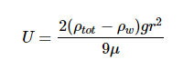

Where ρtot is the density of the particle, ρw is the density of the surrounding liquid (in this case water), r is the radius of the particle, g is the constant of gravitational acceleration (9.8 m s-2), and μ is the dynamic viscosity of surrounding liquid (water).The extended model presented by Miklasz and Denny (2010) assumes constants of ρw = 1023 kg m-3 and μ = 1.07 x 10-3 Pa s, which represents the density and dynamic viscosity of water at 20°C and 33 g L-1 salinity, respectively. Stokes’ law holds up for particles with small Reynolds numbers (Re < 1), which encompasses all particles mentioned in this paper. Since both dynamic viscosity and water’s density varies with temperature and salinity, it is important to consider both variables within our calculation. However, because the range at which water’s density varies with respect to temperature and salinity differences is so small, we can safely assume water to have a constant density of ρw ≈ 1023 kg m-3. Since dynamic viscosity is a large factor in this equation (*need to write state why*), we include the variation of dynamic viscosity within our calculation. In order to calculate the change in dynamic viscosity, we use a seawater toolbox that estimates dynamic viscosity of seawater given temperature and salinity (Sharqawy et al 2010).

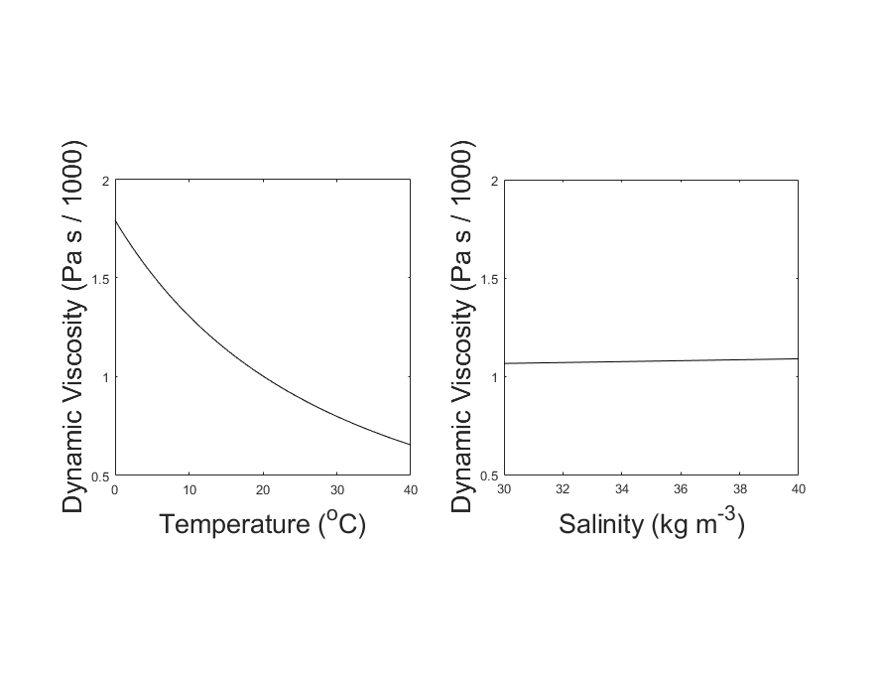

**Figure 1:** Variation in Dynamic Viscosity of Seawater (μ). Viscosity is plotted against temperature, while holding salinity constant at 35 kg m-3 (left). Viscosity is also plotted against salinity, while holding temperature constant at 20oC (right). Over the normal range of each variable, the change in viscosity is dominated by the effect of Temperature.

**(viscosityplot.m)**

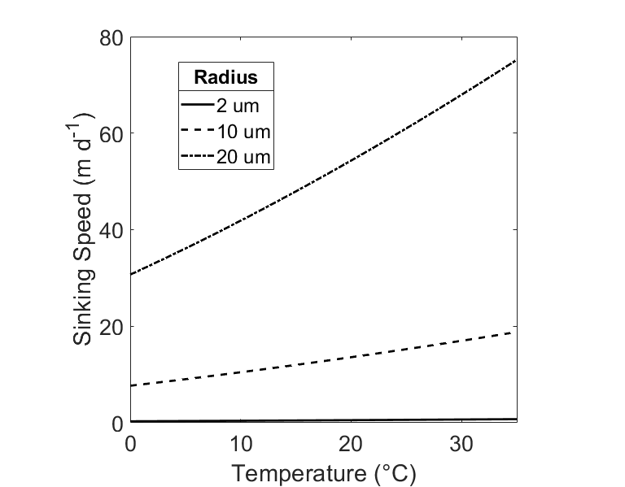

**Figure 2:** Sinking speed (U) in meters per day, calculated by Stokes’ Law. Hypothetical radius values of r = 2 μm (dashed), r = 10 μm (solid), and r = 20 μm (dot / dash) are displayed. Temperature range is 0oC ≤ T ≤35oC, Salinity S = 35 ppt, total cell density ⍴tot = 1800 kg m-3.

**(SpeedPlot_Viscosity_Density_Temperature.m)**

1. Global Maps of Important Environmental Variables that are measured by satellite (T, S, μ)

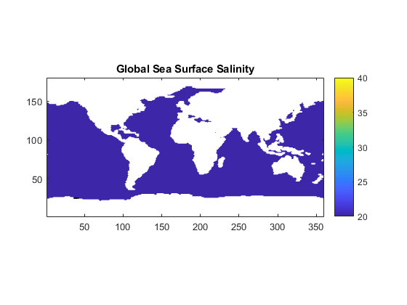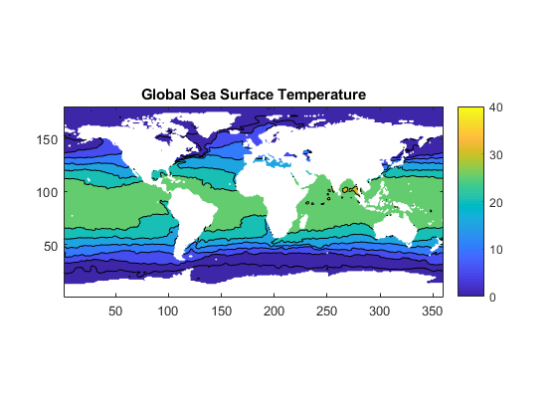

(C_biomass.m)

B. Particle Size and Sinking Speed

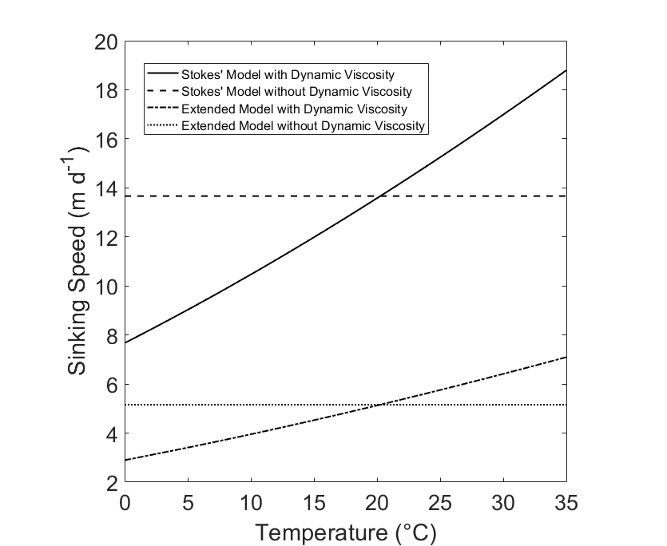

**Figure ( ):** Comparisons between Stokes Model and Extended Model. Temperature range is 0oC ≤ T ≤ 35oC, Salinity S = 35 ppt. The basic Stokes Model assumes a cell radius of r = 10 μm and a uniform cell density of ⍴tot = 1800 kg m-3 (“Stokes’ Model”). The Extended Model assumes a cell radius of r = 10 μm, a frustle thickness of t = 1 μm, a cytoplasm density of ⍴cyt =1065 kg m-3, and a frustle density of ⍴fr = 1800 kg m-3 (“Extended Model”). Each model is presented with and without the influence of dynamic viscosity.

**(StokesDennysPlot.m)**

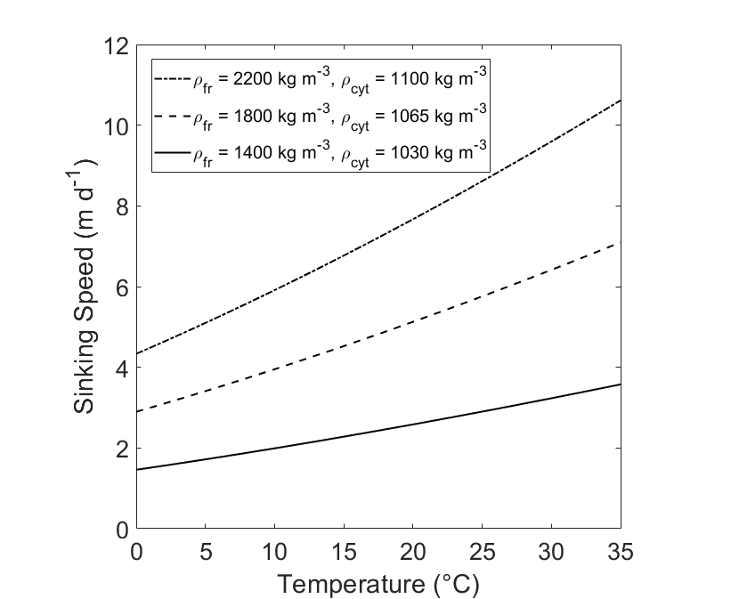

**Figure ( ):** Comparison of Sinking Speed (U) of diatoms at different densities. Sinking Speeds are calculated using the Extended Model. The hypothetical diatoms have radius r = 10 and frustle thickness t = 1 μm

**(VariableDensity.m)**

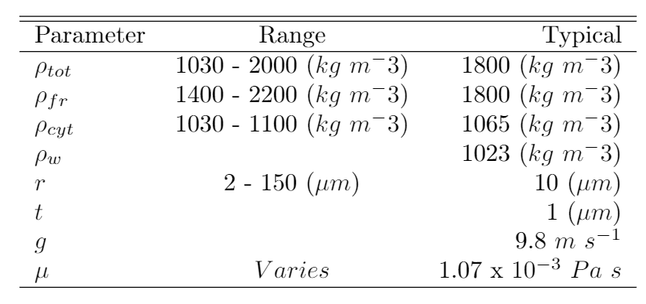

**(LaTeX doc)**

C. Particle Size Distribution and Global Carbon Flux Estimates

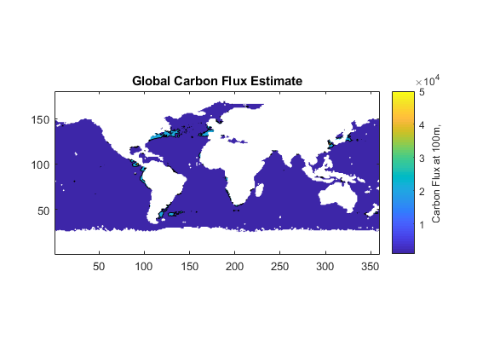

(C_Biomass.m)

**Sediment Trap Data**

**Comparisons Between Data**

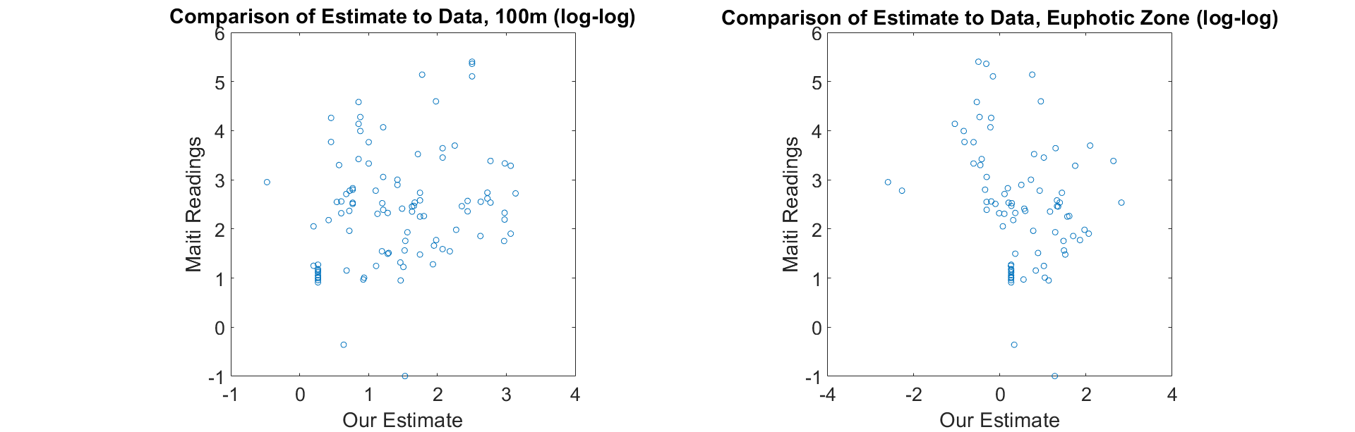

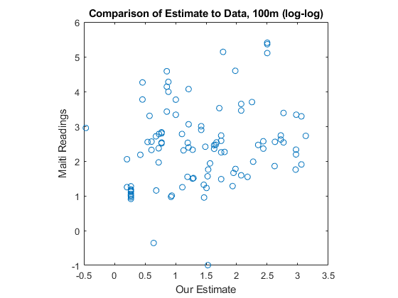

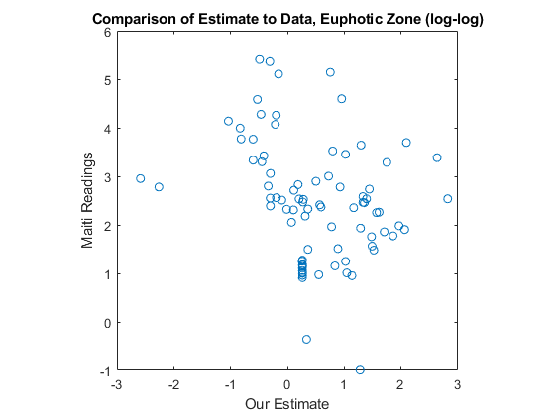

(C_biomass.m)

**Discussion**

**Citations**

Kostadinov, T. S., Siegel, D. A., & Maritorena, S. (2009). Retrieval of the particle size distribution from satellite ocean color observations. Journal of Geophysical Research, 114(C9). <https://doi.org/10.1029/2009jc005303>

Kostadinov, T. S., Milutinovic, S., Marinov, I., & Cabré, A. (2016). Size-partitioned phytoplankton carbon concentrations retrieved from ocean color data, links to data in NetCDF format, supplement to: Kostadinov, Tihomir S; Milutinovic, Svetlana; Marinov, Irina; Cabré, Anna (2016): Carbon-based phytoplankton size classes retrieved via ocean color estimates of the particle size distribution. Ocean Science, 12(2), 561-575 [Data set]. PANGAEA - Data Publisher for Earth & Environmental Science. <https://doi.org/10.1594/pangaea.859005>

Nayar, K. G., Sharqawy, M. H., Banchik, L. D., & Lienhard V, J. H. (2016). Thermophysical properties of seawater: A review and new correlations that include pressure dependence. Desalination, 390, 1–24. <https://doi.org/10.1016/j.desal.2016.02.024>

Sharqawy, M. H., Lienhard V, J. H., Zubair, S. M. (2010). Thermophysical Properties of seawater: A review of existing correlations and data. Desalination and Water Treatment, 16, 354-380.

<http://web.mit.edu/lienhard/www/Thermophysical_properties_of_seawater-DWT-16-354-2010.pdf>

Siegel, D. A., Buesseler, K. O., Doney, S. C., Sailley, S. F., Behrenfeld, M. J., & Boyd, P. W. (2014). Global assessment of ocean carbon export by combining satellite observations and food-web models. Global Biogeochemical Cycles, 28(3), 181–196. <https://doi.org/10.1002/2013gb004743>